

BURGER STATION

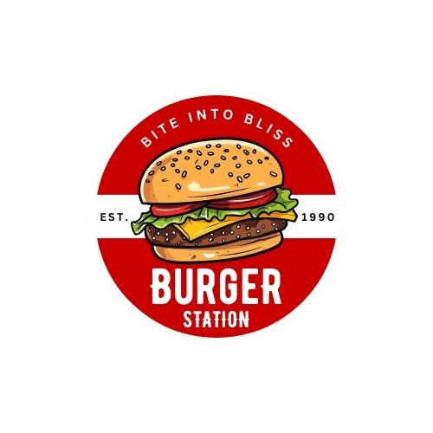

***LOGO FOR THE BURGER SHOP***

COLOUR CODES

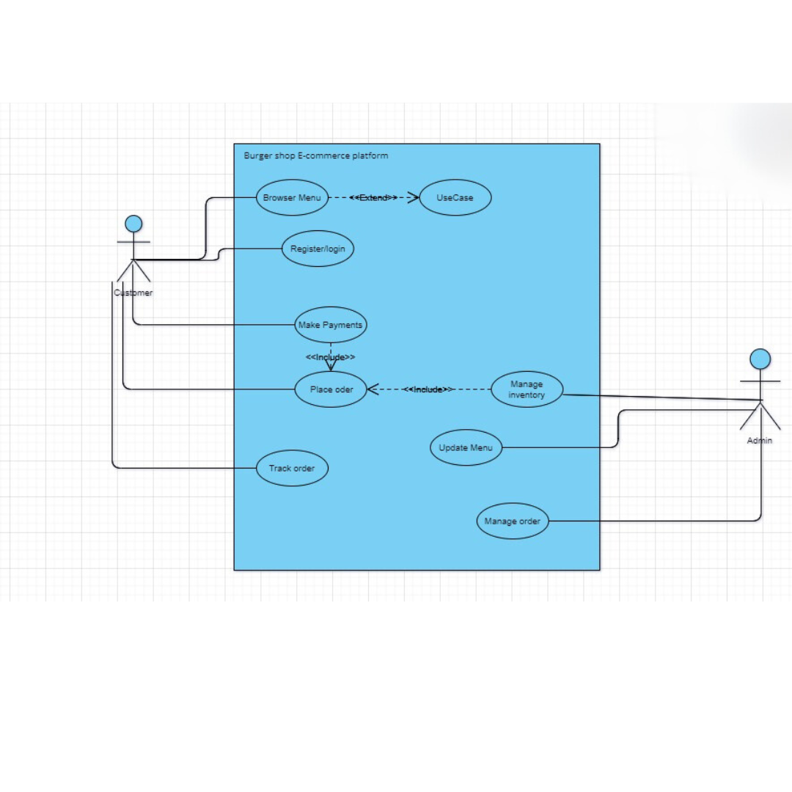**1.Use Case Diagram**

**2.Functional and Non-Functional Requirements**

* **Functional Requirements**
* User must able to register them self to the website
* User must able to update there personal information and view order history
* User must able to view the Menu
* User must able to add items to a shopping cart
* User must able to place order
* User must able to do online payments
* User must able to track the order status
* **Non-Functional Requirements**
* The website should load within 3 seconds.
* The website should handle at least 500 users at once without buffer.
* User data should be encrypted both in transit and at rest.
* The website should have a user-friendly interface.
* The website should provide clear and easy navigation.

**3.Wire-farme**

<https://www.figma.com/design/8pYYL8LVddBZTLtHuQUxAZ/Untitled?node-id=0-1&t=Z0y1pElCm03SPj3k-1>

**4.Prototype**